ENGR 321 – Project 1 Report Workbook
Drone Delivery Data Dashboard Design
Andrew York | September 17, 2026

Part 1 – Customer Development

Goal of the drone delivery app project
The goal is to create a fast, precise, and safe drone delivery app that is simple enough for everyday users. The system should make ordering basic necessities easy, provide clear delivery tracking, and work around limits such as weather, distance, payload weight, and safe drop-off locations.

Problem statement
Drone delivery can be faster and more convenient than traditional delivery, but the user still needs to trust that the correct address is used, the drop zone is safe, the package is secure, and the drone can complete the trip. Weather, battery range, payload weight, pricing, and confusing drone terminology can also make the service harder to use. This project addresses those gaps with a simple ordering flow, clear status information, delivery instructions, live flight information, and multiple ways to confirm that an order was received.

Customer development work
Customer | Role in ecosystem | Needs | Pain points
Older adult / mobility-limited user | Recipient | Simple interface, medicine/grocery access, clear updates | Small text, confusing steps, difficulty traveling to stores
Rural resident | Recipient | Fast access to necessities over longer distances | Long travel times, limited nearby stores, drone range/weather limits
Suburban resident | Recipient | Convenience, safe drop-off, fair pricing | Privacy concerns, weather, package security, noise
City resident | Recipient | Fast delivery and accurate tracking | Crowded drop zones, buildings/obstacles, safety concerns
Drone operator / dispatcher | Operations | Clear order details, safe route, battery and status visibility | Bad addresses, unsafe drop zones, low battery, weather changes

Participant selection & methodology
The customer-development plan focuses on people with different delivery needs: older or mobility-limited users, rural residents, suburban/city residents, and a drone operator perspective. Short interviews or usability sessions would ask what they normally order, what makes delivery frustrating, what information they need during a delivery, and what would make them trust or avoid a drone delivery service. These are planned customer profiles and questions; formal human-subject interviews have not yet been completed.

Key findings and insights summarized
The preliminary needs analysis shows that time, cost, simplicity, safety, and clear information are the main concerns. The app should avoid technical drone language, make ordering basic items quick, show the user where the delivery is in the process, and make the final handoff easy to understand. Older or less technical users especially benefit from a simple layout and obvious status updates.

Real challenge identified and how it was solved
The main design challenge was making a technically complex drone system feel like a normal delivery app. The prototype solves this by hiding unnecessary flight-control details and showing only useful information such as order status, route progress, battery, altitude, speed, estimated time, and delivery confirmation. The user can focus on receiving the order instead of understanding drone operations.

Part 2 – App Design

System design
The prototype follows a simple delivery flow: choose a store → choose items → review the cart → enter the recipient/address and delivery notes → place the order → track the drone → confirm delivery → view the completed order in history. The app also checks the flight path automatically and gives the user clear status messages throughout the delivery.

Design rationale
Customer needs shaped the design toward simplicity, visibility, and safety. Store categories and item lists make ordering familiar, while plain-language status labels such as “On the way” and “Delivered” reduce confusion. Delivery notes, automatic flight-path checking, live telemetry, and multiple confirmation methods were added to improve trust and give users useful control without overwhelming them.

Hardware/software components and testing method
The current deliverable is a front-end software prototype built as a single HTML page using React, JavaScript, HTML, and CSS. It simulates store selection, a shopping cart, address entry, drone dispatch, flight progress, battery/altitude/speed data, delivery confirmation, and order history. Testing can be performed by running complete task scenarios in a web browser, checking that each screen changes correctly, required fields prevent incomplete orders, tracking updates are understandable, and delivery confirmation is recorded.

Code / prototype link
GitHub repository: https://github.com/Andrew-York-04/drone-delivery-app
Live prototype: https://andrew-york-04.github.io/drone-delivery-app/
The GitHub repository contains the working NoPriorITies prototype and project README. The GitHub Pages link opens the live browser-based prototype so the complete ordering, tracking, confirmation, and order-history flow can be demonstrated.

Part 2 Visual Design – Workflow, UI Flow, and Wireframe/Mockup
The visuals below show how the original delivery workflow was translated into the final NoPriorITies interface. The system workflow includes the normal delivery path plus the problem-detection, emergency-abort, return-to-base, and customer-support path required by the project. The UI/UX flow then shows the simplified customer-facing sequence used in the working prototype.
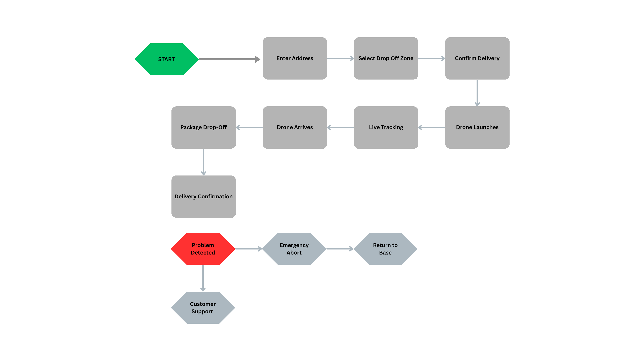
Figure 1. Original system workflow showing address entry, drop-off selection, live tracking, delivery confirmation, and the emergency abort/return-to-base path.
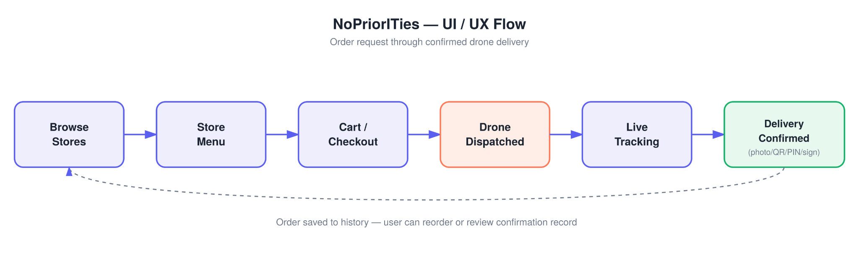
Figure 2. NoPriorITies UI/UX flow from store browsing through confirmed drone delivery and order history.
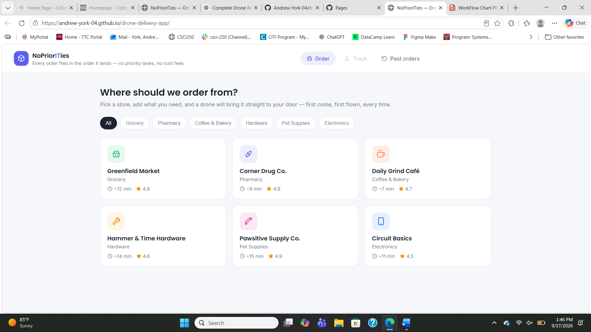
Figure 3. Wireframe/mockup – store browsing screen with delivery categories and estimated flight times.
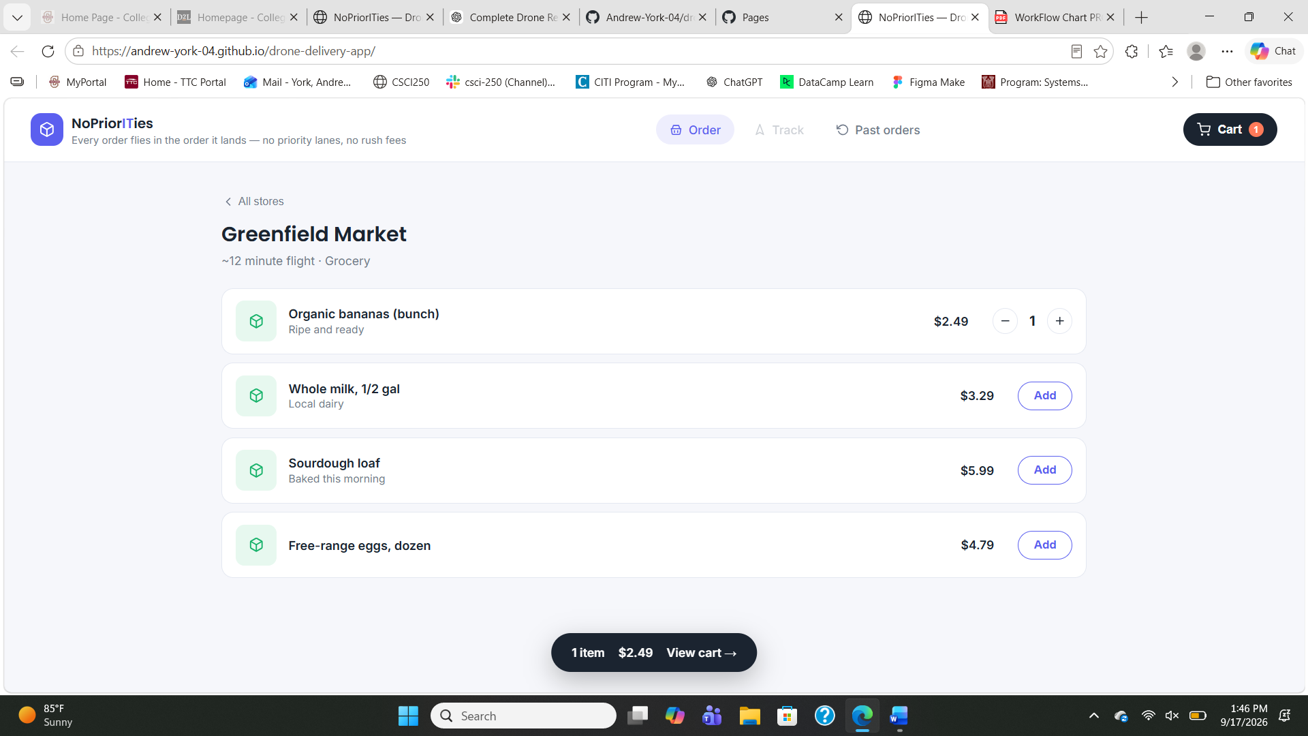
Figure 4. Wireframe/mockup – store menu and cart interaction.
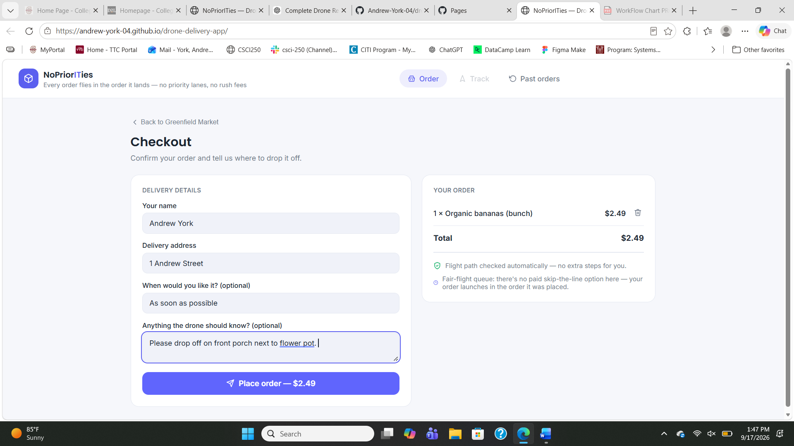
Figure 5. Wireframe/mockup – checkout screen with recipient, address, timing, and drop-off instructions.
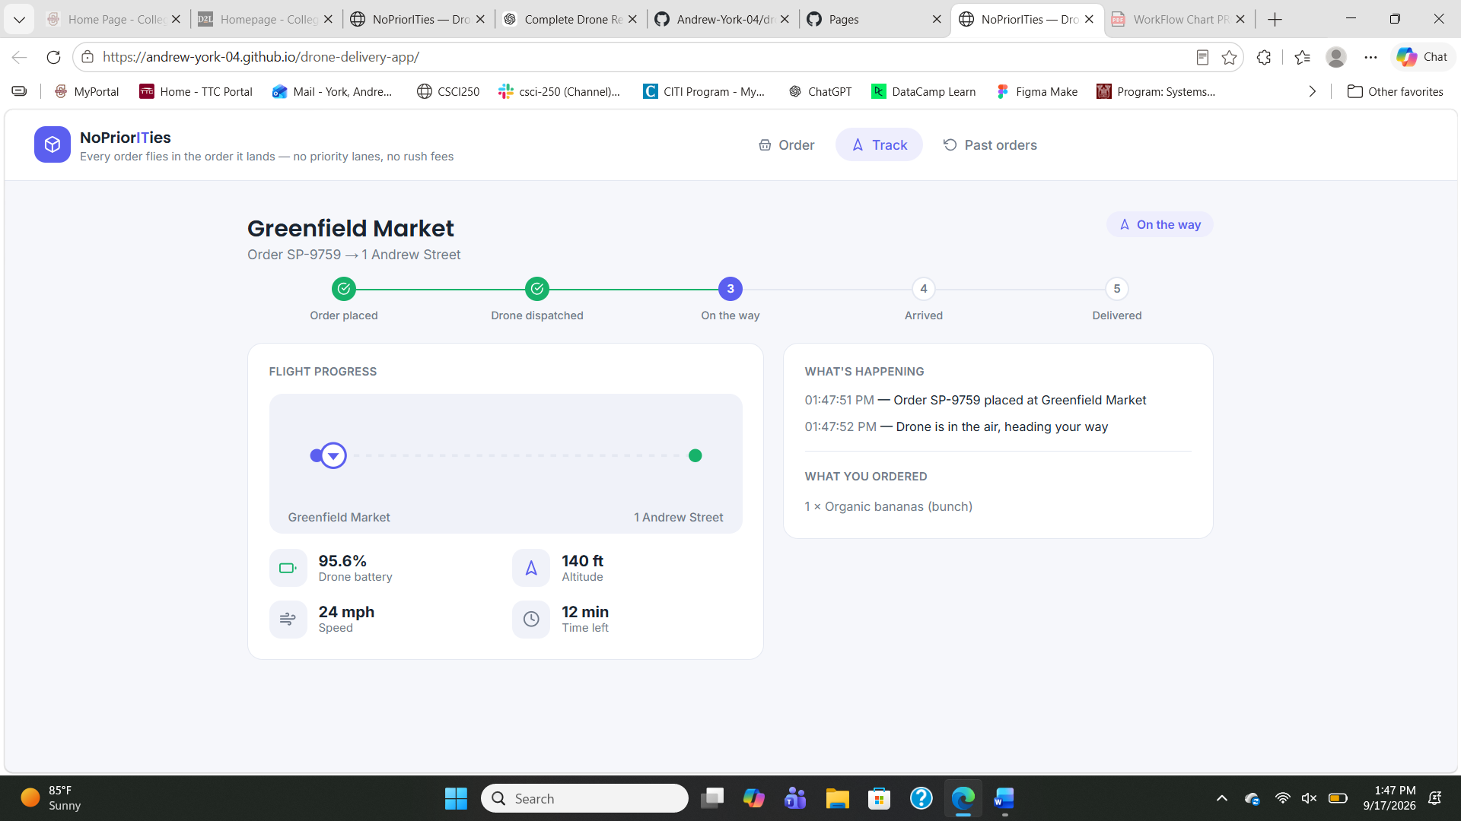
Figure 6. Wireframe/mockup – live tracking screen showing delivery status, flight progress, battery, altitude, speed, and time remaining.
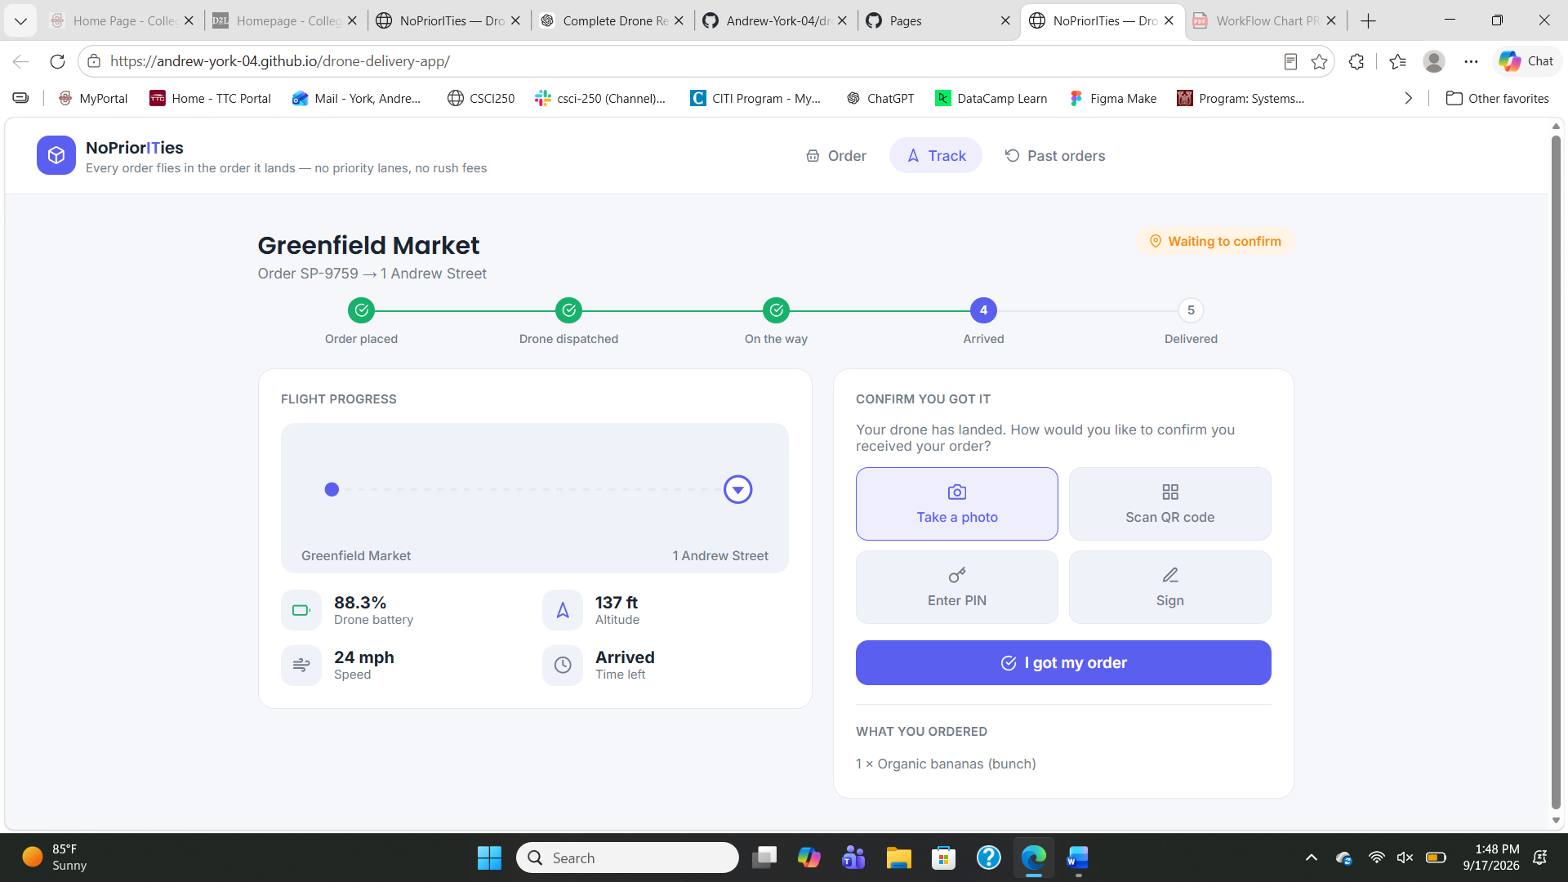
Figure 7. Wireframe/mockup – delivery-arrival screen with photo, QR code, PIN, and signature confirmation options.
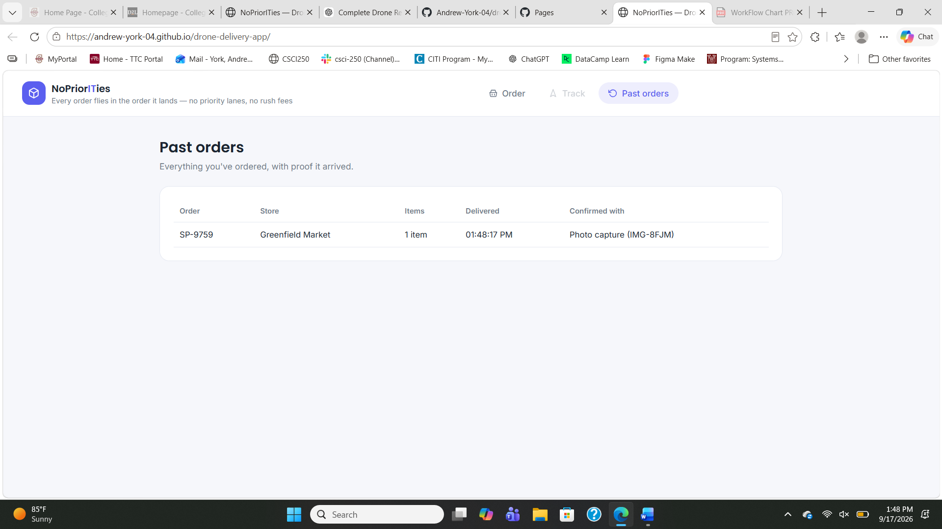
Figure 8. Wireframe/mockup – past-orders screen showing the completed order and confirmation record.
Together, these screens demonstrate the full customer task sequence: selecting a store and item, entering delivery information, placing an order, monitoring the drone, confirming receipt, and reviewing the completed order. The interface uses plain-language status labels and only exposes flight information that is useful to the customer, supporting the project's human-factors focus on safety, situation awareness, low mental workload, and usability.

Part 3 – App Evaluation Plan

Evaluation framework
The evaluation will use a SOFIT-style human-factors approach focused on the user’s performance and experience during realistic delivery tasks. Two main measures will be used: a Situation Awareness Rating Technique (SART) to check whether users understand the drone’s status and what is happening, and NASA-TLX to measure perceived mental workload after completing the delivery flow. This fits the project because the interface must keep users informed without making the task stressful or mentally demanding.

Who would conduct the evaluation and their background?
The evaluation could be conducted by the student designer with guidance from the ENGR 321 instructor or another person familiar with human factors and usability testing. Participants should include people with different levels of technology experience so the design can be evaluated for both confident app users and users who may need a simpler interface.

SOFIT methods and task-based evaluation plan
Method / measure | What it evaluates | Planned task
Task observation | Errors, hesitation, navigation problems | Choose a store and item, enter delivery information, and place an order without assistance.
SART | Situation awareness and understanding of system state | During tracking, ask the user to identify the drone status, location/progress, battery level, and estimated time.
NASA-TLX | Mental workload, effort, frustration, and perceived demand | After completing an order and delivery confirmation, have the user rate the workload of the full task.
Completion time & errors | Efficiency and usability | Record time, wrong clicks, missed fields, and help requests from store selection through confirmation.
Post-task satisfaction questions | Overall usability and trust | Ask whether the user would feel comfortable using the service and which screen or message was least clear.

Anticipated evaluation metrics and success criteria
Success would mean most users can place and track an order without assistance, correctly identify the drone’s current status, and confirm delivery without major errors. The evaluation would also look for low task time, few wrong clicks, low-to-moderate NASA-TLX workload ratings, strong SART situation-awareness ratings, and positive user satisfaction. Any repeated confusion or missed information would be treated as a design issue to improve.

Connection to human-factors theory
The design supports human information processing by using short labels, icons, grouped information, and a step-by-step flow instead of showing too much at once. Live status, route progress, battery, and time-left information support situation awareness, while the simple screens are intended to reduce mental workload and stress. Multiple delivery-confirmation options also make the system more adaptable to different users, supporting usability and a co-adaptive human-machine interaction.

Closing

Future scope
Future work could connect the interface to real mapping, weather, geofencing, payment, and drone telemetry services instead of simulated data. The app could also add accessibility options, membership/rewards, different drone types based on payload and weather, automatic return-to-base controls, and support for rural, medical, campus, or emergency delivery use cases.

Conclusion
This project developed a user-centered prototype for ordering, tracking, and confirming drone deliveries. Part 1 identified the main user needs and constraints, Part 2 turned those needs into a working browser prototype, and Part 3 created a human-factors evaluation plan using situation awareness, workload, performance, and satisfaction measures. The prototype meets the main design goal at the interface level, while real drone integration and formal user testing remain future work.

Deliverables checklist
☒ Written report covering Parts 1–3 and Closing (completed)
☒ Working Data Dashboard / app prototype (HTML file available)
☒ GitHub repository link included
☒ Live demo ready and hosted with GitHub Pages

